ĐỀ CƯƠNG ÔN TẬP CUỐI NĂM MÔN TIẾNG ANH LỚP 2

(I learn Smart Start 2)

I. Tổng hợp từ vựng và mẫu câu từ Unit 6 đến Unit 10

Sttt | TỪ VỰNG | CẤU TRÚC CÂU
1 | - Unit 6: Around Town (Vòng quanh Thị trấn)  Các từ: zoo, beach, park, playground, rabbit, tiger, sea, top, umbrella.  Các âm của các chữ cái: Tt, Rr, Ss, Uu. | Tôi muốn đến đâu đó.  I want to go to the park – Tôi muốn đi đến công viên.
2 | - Unit 7: Clothes (quần áo)  Các từ chỉ trang phục: shirt, T-shirt, dress, hat, pants, shorts, shoes, socks  Các từ: violin, vest, banana, apple.  Các âm của chữ cái: Vv, Ww | Các câu hỏi đoán về Trang phục.  Is this your T-shirt?  Yes, it is/ No, it isn’t.  Câu giới thiêu về Trang phục.  These are my pants.  Câu mời ai ăn gì.  Bananas?  Yes, please/ No, thanks
3 | Unit 8: Trasportation (Phương tiện giao thông)  Các từ: bus, plane, motorbike, boat, car, fox, yo, y, yogurt, see  Các âm của chữ cái: Xx, Yy | Câu hỏi đoán.  Can you see the car?  Yes, I can/ No, I can’t.  Kể xem có cái gi.  I have a yo-yo
4 | Unit 9: Classroom Activities (Các hoạt động ở lớp học)  Các từ: eraser, ruler, crayon, pencil case, zebra, zoo, count numbers, draw pictures, sing songs, play soccer. | Câu lệnh.  Pic up your ruler!  Kể xem mình biết làm gì.  I can count numbers.
5 | Unit 10: Days of the week (Các thứ trong tuần)  Các từ: Monday, Tuesday, Wednesday, Thursday, Friday, Saturday, Sunday | Câu hỏi về thứ:  What day is it?  It’s Monday.

II. Các đề mẫu.

ĐỀ SỐ 1
I/ LISTENING: (2pts.)
Listen and tick (√) or cross (X)

1.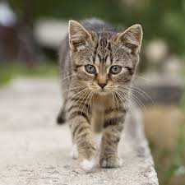 | 2. | 3.  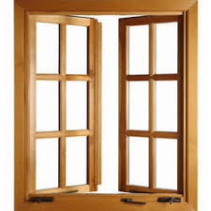 | 4.  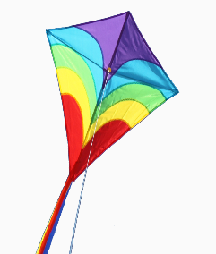 | 5.
√
󠄼󠄼 󠄼󠄼 󠄼󠄼 󠄼󠄼
II/ FILL ONE LETTER IN EACH GAP TO COPMLETE THE WORDS:
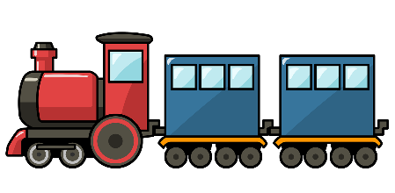 |  | 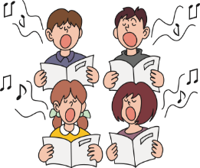
- tr__ in |  | - s___ng a song
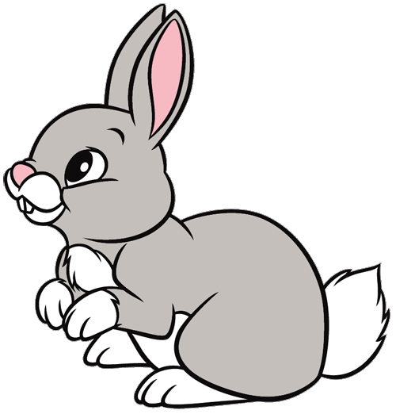 |  | 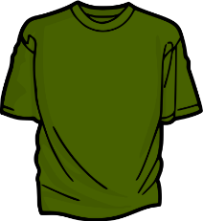
- rab__i t |  | - T- s__irt

III/ CIRCLE THE ODD ONE OUT
1 | - a T.V | - a chair | - a bed | - a salad
 |  | 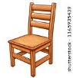 | 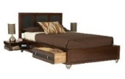
2 | - a hat | - a coat | - a train | - a cap
 | 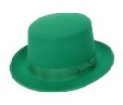 |  | 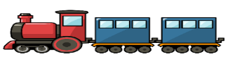 | 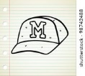
3 | - a gate | - a window | - pictures | - a door
 | 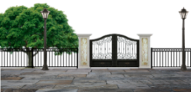 | 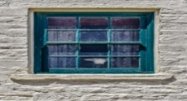 |  | 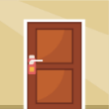
4 | - Monday | - Sunday | - Friday | - A week
5 | - where | - clock | - what | - who
 |  | 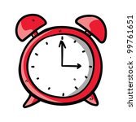
6 | - a cat  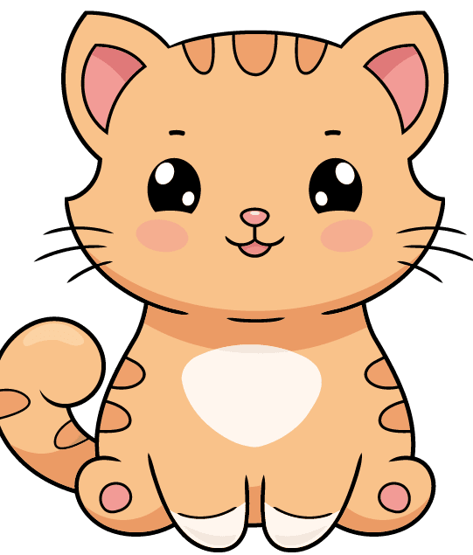 | - a monkey  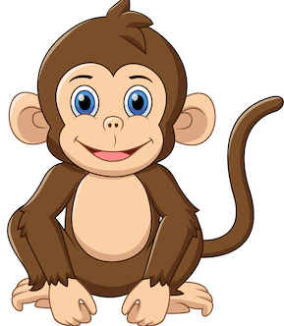 | - a duck  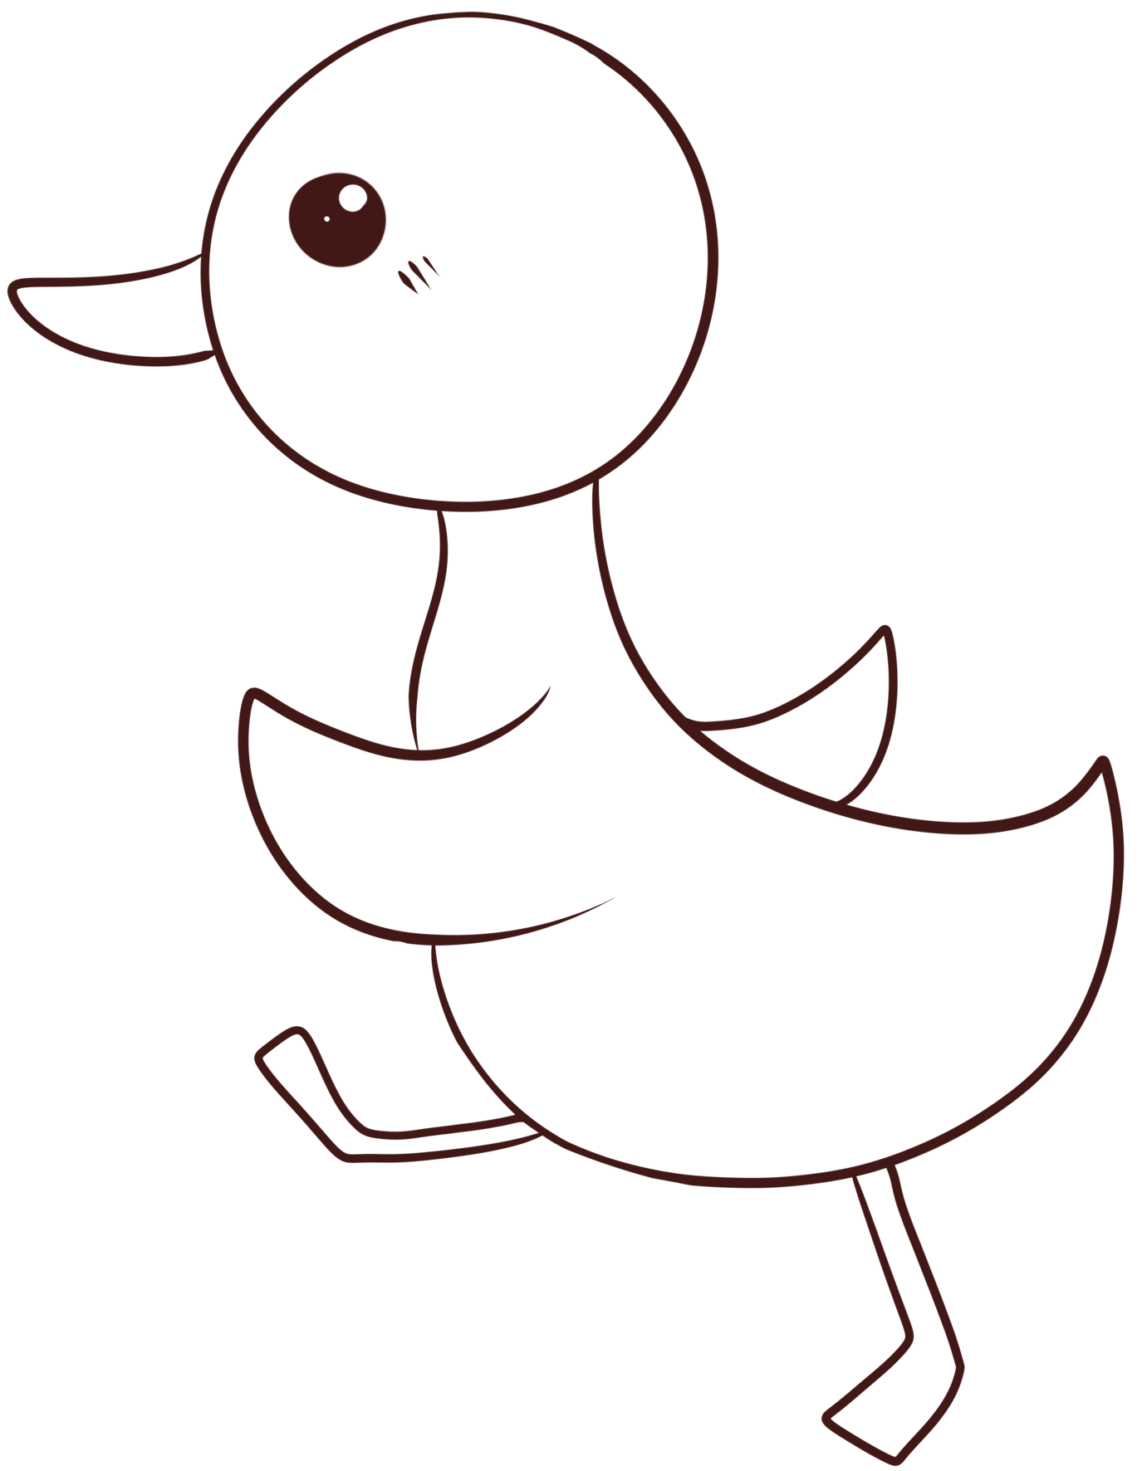 | - a dog  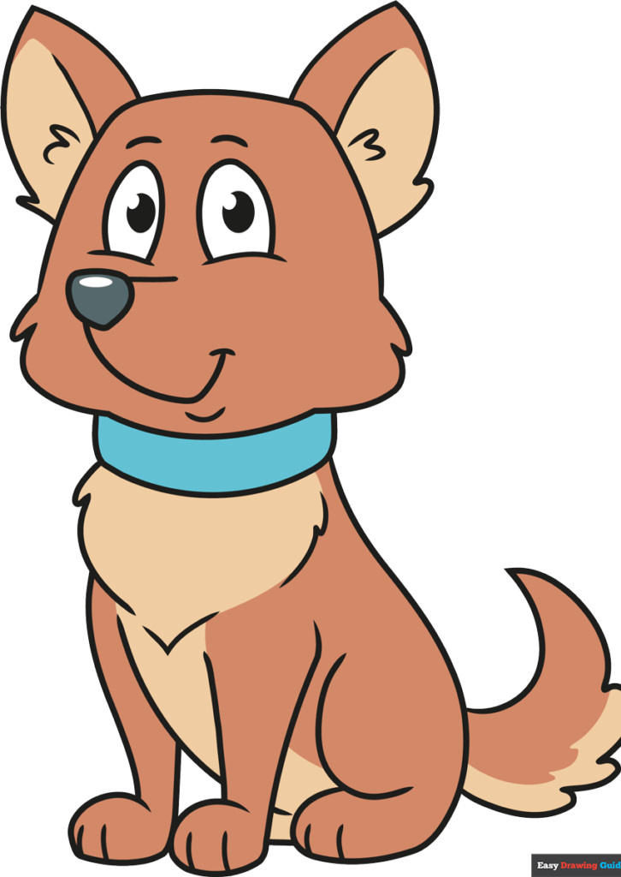

IV/ CIRCLE THE CORRECT ANSWERS
- Can you ______ the bus?
- see B- look C- meet
- What day _______ today?
- are B- is C- be
- _______ are my shoes.
- This B- That C- These
- Is this your bag? – ___________.
- Yes, it is B- No, it is C- Yes, it isn’t
- I want __________ to the zoo.
- go B- to go C- going
- Can you _______ numbers?
- playing B- counting C- count
ĐỀ SỐ 2
I/ FILL ONE LETTER IN EACH GAP TO COPMLETE THE WORDS:
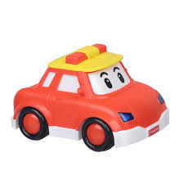 |  | 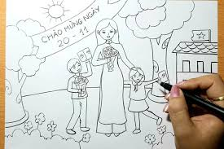
1. c _ r |  | 2. d _ aw pictures
3. pla _ e |  | 4. ha _

II/ CIRCLE THE ODD ONE OUT
1 | A. a car | B. a dog | C. a plane | D. a bike
 |  |  |  | 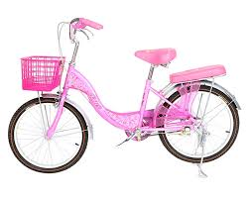
2 | A. a doll | B. shorts | C. a shirt | D. a cap
 | 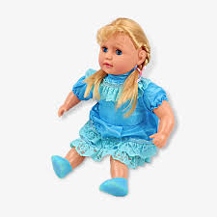 | 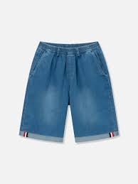 | 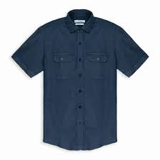 | 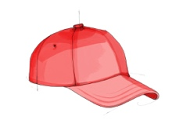
3 | A. a gate | B. a window | C. p | D. a door
 | 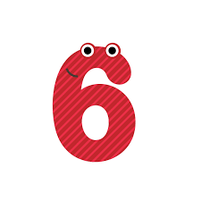
4 | A. a cat | B. Sunday | C. a dog | D. a monkey
5 | A. play soocer | B. clock | C. play badminton | D. sing songs
 | 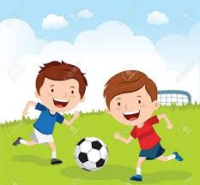
6 | A. a cap | B. a shirt | C. a duck | D. a coat

III/ CIRCLE THE CORRECT ANSWERS
1. _____ you see the car?
A. Do B- Are C- Can
2. I _______ a yo-yo
A. am B- have C- can
3. These are my ________.
A. dress B- hat C- socks
4. Is this your hat? – _________.
A. Yes, it is B- No, it is C- Yes, it isn’t
5. I want to go to _____zoo.
A. a B- the C- for
6. Can you _______ pictures?
A. draw B- drawing C- to draw

ĐỀ SỐ 3
I/ FILL ONE LETTER IN EACH GAP TO COPMLETE THE WORDS
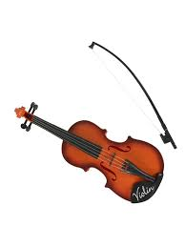
1. v _ oli |  | 2. s _ ng songs
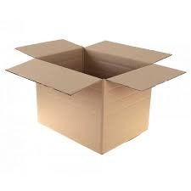
3. bo _ |  | 4. c _ p

II/ CIRCLE THE ODD ONE OUT
1 | A. a car | B. a chair | C. a plane | D. a bike
2 | - a doll | - a coat | - a shirt | - a cap
3 | A. a yo-yo | B. a car | C. a door | D. a kite
 |  |  |  | 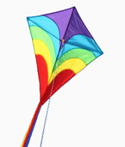
4 | - Monday | - Sunday | - Friday | - A week
5 | - where | - clock | - what | - who
6 | - a cat | - a monkey | - a duck | - a dog

III/ CIRCLE THE CORRECT ANSWERS
1. I _______ to go to the beach.
A. wants B- want C- am
2. Let’s ___________ soocer.
A.. go B- sing C- play
3. These are ________ toys.
A. you B- my C- I
4. Is this your ruler? – _________.
A. Yes, I do B- Yes, it is C- Yes, it isn’t
5. Milk? – Yes, ______________
A. Ok B- like C- please
6. Can you _______ songs?
A. singing B- sing C- to sing
IV. Read and match

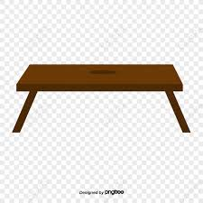

Xx Vv Tt

ĐỀ SỐ 4
I/ FILL ONE LETTER IN EACH GAP TO COPMLETE THE WORDS:
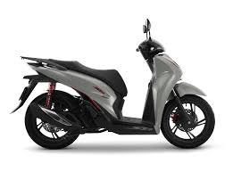
1. moto_bike |  | 2. play so_cer
3. c_at |  | 4. t_n

II/ CIRCLE THE ODD ONE OUT
1 | A. a car | B. a chair | C. a plane | D. a bike
2 | A. a doll | B. a coat | C. a shirt | D. a cap
3 | A. a gate | B. a window | C. ten | D. a door
4 | A. Monday | B. Sunday | C. Friday | D. A week
5 | A. where | B. clock | C. what | D. who
6 | A. shorts | B. dress | C. shoes | D. socks

III/ CIRCLE THE CORRECT ANSWERS
1. _____ you see the car?
A. Do B- Are C- Can
2. I _______ a yo-yo
A. am B- have C- can
3. These are my ________.
A. dress B- hat C- socks
4. Is this your hat? – _________.
A. Yes, it is B- No, it is C- Yes, it isn’t
5. I want to go to _____zoo.
A. a B- the C- for
6. _______ day is it?
A. Where B- What C- Who
IV. Read and match
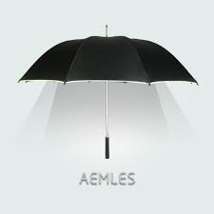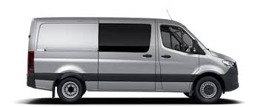

Uu Yy Vv

ĐỀ SỐ 5
I/ FILL ONE LETTER IN EACH GAP TO COPMLETE THE WORDS:
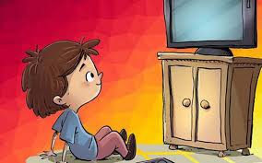 |  | 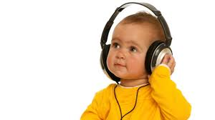
1. wa_ch TV |  | 2. li_ten to music
3. pla _ e |  | 4. ha _py

II/ CIRCLE THE ODD ONE OUT
1 | A. a car | B. a chair | C. a plane | D. a bike
2 | A. a doll | B. a coat | C. a shirt | D. a cap
3 | A. a gate | B. a window | C. p | D. a door
4 | A. can | B. go | C. have | D. see
5 | A. happy | B. scared | C. I | D. tired
6 | A. fourteen | B. thirteen | C. eleven | D. number

III/ CIRCLE THE CORRECT ANSWERS (3 pts.)
1. What can you _______ ?
A. see B- want C- like
2. I _______ a yo-yo
A. am B- have C- can
3. _______ are my shirt.
A. This B- They C- These
4. Is this your hat? – _________.
A. Yes, it is B- No, it is C- Yes, it isn’t
5. I want ____ go to the zoo.
A. at B- for C- to
6. Can you listen to __________?
A. TV B- music C- computer
IV. REODER THE WORDS TO MAKE SENTENCE
1. the/ bus/ see/ Can/?
______________________________________________________________________________
2. your/ cat/ Is/ this/?
______________________________________________________________________________
3. my/ shoes/ These/ are/.
______________________________________________________________________________
4. can/ count/ I/ numbers/.
______________________________________________________________________________

